April 4, 2023

The Canadian Snowcross Racing Association (CSRA) final rounds of the 2023 season took place at Horseshoe Resort in Barrie, ON. The Ultimax Snowcross Finals presented by St.Onge Recreation, Truenorth Motorsports & Tom Smith Chevrolet. Three days of racing included kids racing, vintage classes, UTV Racing, kids annual Easter Egg hunt and so much more!

Friday racing featured all of our racing classes from 120s to Pro Open! Our Sport 600 class saw #632 Eric Bouskill (Ski-Doo) from Bracebridge, ON in 1st. #281 Jacob Begin (Ski-Doo) from Saint Georges, QC was 2nd, followed by #914 Andrew Ruggle (Arctic Cat) from Floradal, ON finished in 3rd.

The Pro Lite class on Friday was dominated by #111 Nathan Mailloux (FXR Racing, Ski-Doo), Ste-Sophie, QC who took the win. #22 Hunter Scott (Motopark, Ski-Doo) from Oro-Medonte, ON who finished in 2nd and #56 Taylor Stewart (London Recreation, Ski-Doo) from Heidelberg, ON was 3rd.

The Pro/Am Womens class was won by #501 Dakota Karkoulas (Ski-Doo, Bailey Motorsports) from Oakwood, ON. #144 Shyann Gosselin (Ski-Doo) from Kapuskasing, ON took 2nd and #574 Hailey Belanger (Bailey Motorsport, Ski-Doo) from Bracebridge, ON was 3rd across the line.

In Fridays Pro Class it was #335 Taylor McCoy (Pro Street, Ski-Doo) from Bracebridge, ON taking the top spot. Points leader to #459 Jake Weir (Royal Distributing, FXR, Polaris) from Bracebridge, ON placed 2nd followed by #912 Deklan Henshaw (Ski-Doo) from Bracebridge, ON in 3rd.

In Saturdays Sport 600 class #458 Trent Weir (Royal Distributing, FXR, Polaris) from Bracebridge, ON went undefeated in his heats and Saturdays final. #632 of Eric Bouskill (Ski-Doo) from Bracebridge, ON was in 2nd followed by #281 Jacob Begin (Ski-Doo) from Saint Georges, QC who finished in 3rd.

In the Pro-Lite class #111 Nathan Mailloux (FXR Racing, Ski-Doo), Ste-Sophie, QC took the checkered flag on Saturday. #98 Michael Island (Polaris) from Coldwater, ON was 2nd followed by #56 Taylor Stewart (London Recreation, Ski-Doo) from Heidelberg, ON who finished in 3rd.

The Pro/Am Women’s class final saw #501 Dakota Karkoulas (Ski-Doo, Bailey Motorsports) from Oakwood, ON taking the win. She was followed by #144 Shyann Gosselin (Ski-Doo) from Kapuskasing, ON in 2nd and #574 Hailey Belanger (Bailey Motorsport, Ski-Doo) from Bracebridge, ON was 3rd.

Saturday’s Sudbury Pro Snowcross win went to #459 Jake Weir (Royal Distributing, FXR, Polaris) from Bracebridge, ON. #9 Cameron Wachtler (Dayco, Arctic Cat) from Torrance, ON placed 2nd. #335 Taylor McCoy (Pro Street, Ski-Doo) from Bracebridge, ON was 3rd.

Sunday’s Sport 600 class was once again dominated by #458 Trent Weir (Royal Distributing, FXR, Polaris) from Bracebridge, ON who took home the win. #281 Jacob Begin (Ski-Doo) from Saint Georges, QC was 2nd and #632 Eric Bouskill (Ski-Doo) from Bracebridge, ON was 3rd.

In the Pro-Lite Class #111 Nathan Mailloux (FXR Racing, Ski-Doo), Ste-Sophie, QC took the win over #22 Hunter Scott (Motopark, Ski-Doo) from Oro-Medonte, ON who placed 2nd. #98 Michael Island (Polaris) from Coldwater, ON finished in 3rd. #111 Nathan Mailloux is the 2023 Pro-Lite Season Champion!

In the Pro/Am Women’s class it was #501 Dakota Karkoulas (Ski-Doo, Bailey Motorsports) from Oakwood, ON in the lead followed by #144 Shyann Gosselin (Ski-Doo) from Kapuskasing, ON in 2nd and #574 Hailey Belanger (Bailey Motorsports, Ski-Doo) from Bracebridge, ON took home 3rd. #501 Dakota Karkoulas finished off the 2023 season as the Pro/Am Womens Season Champion!

Sundays Pro Final saw #459 Jake Weir (Royal Distributing, FXR, Polaris) from Bracebridge, ON dominating the weekends heats and finals. #9 of Cameron Wachtler (Dayco, Arctic Cat) from Torrance, ON placed 2nd. #335 Taylor McCoy (Pro Street, Ski-Doo) from Bracebridge, ON was in 3rd. This victory would clinch #459 Jake Weir’s 2023 season Pro Championship title. Weir won a new Chevy 3500 High-Country dually sponsored by Tom Smith Chevrolet and True North Motorsports for a year.

Saturdays UTV 1000cc Production class #72 Ken Avann (Polaris) from Suttonwest, ON taking the win. Avann was followed by #357 Thomas Beadown (Kawasaki) from Kapuskasing, ON in 2nd. #308 Aaron Dipietro (Kawasaki) from Caistor Centre, ON was able to hold on for 3rd place.

The UTV Production 1000cc Turbo class saw #72 Ken Avann (Royal Distributing, Polaris) from Suttonwest, ON out front for the win. #876 Tom Bennet (Bennet Marine, Can-Am) finished 2nd. #182. Gavin Caissie (Can-Am) from Kitchener, ON finished in 3rd. #72 Ken Avann is your 2023 UTV Production 1000cc Turbo season Champion! Avann takes home the grand prize of a brand new GMX AT4X sponsored by Tom Smith Chevrolet and True North Motorsports for a year!

Thank you to all of our Racers, Race Teams, Sponsors and Crew for a fantastic and exciting 2023 CSRA season. Full season points results will be available shortly and we look forward to seeing everyone at the 2023 CSRA Awards Banquet. Find out more at www.snowcross.com or email info@snowcross.com

For full results in all classes visit www.snowcross.com
Stay up to date with CSRA news on Facebook & Instagram
Facebook.com/snowcross @CSRAsnowcross
CSRA thanks our series sponsors:
Sunoco Race Fuels, Ultimax Performance Belts by Timken, OSM On Snow Magazine, FXR Racing, Royal Distributing, Motul Lubricants, True North Motorsports, Tom Smith Chevrolet Buick GMC, Stud Boy Traction Products, Edge Performance, St-Onge Recreation, Giesler Marine, OTSFF Sports Marketing, C&A Pro Skis, Vision Wheel, Black River Racing, Team Vincent Motorsports, Caliber, Woody’s, ACS Powersports, JD Racing, Algonquin Equipment, Sheppard Racing, Team Gelinas, Sault Ste. Marie, Action Trailers, HB Cycle, Mikey’s General Sales, Bailey Motorsports, Lee Plumbing, Polito Ford Lincoln, Rigid, Tekrider TekVest, Cyclone Motorsports, Clean Media, ATV World Magazine, Bayside Chrysler Dodge Jeep Ram, BRP Ski-Doo, Can-Am, Polaris RZR, TIMBERSLED, Polaris Industries Canada and Backcountry Motorsports Media

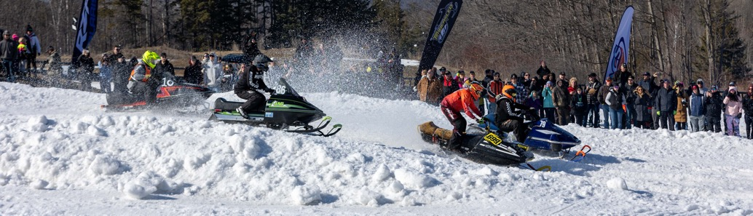
Vintage Racing made its’ annual return to the final round of the 2023 CSRA Season at Horseshoe Valley!

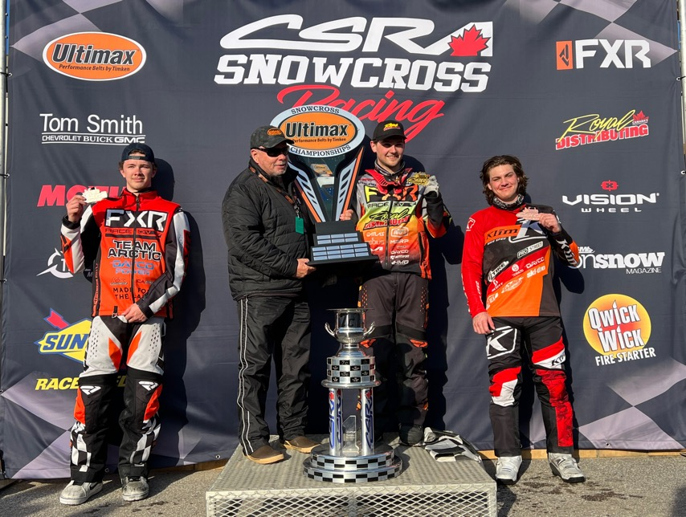
#459 Jake Weir takes the 2023 season Pro Championship title. Weir won a new Chevy 3500 High-Country dually sponsored by Tom Smith Chevrolet and True North Motorsports for a year.

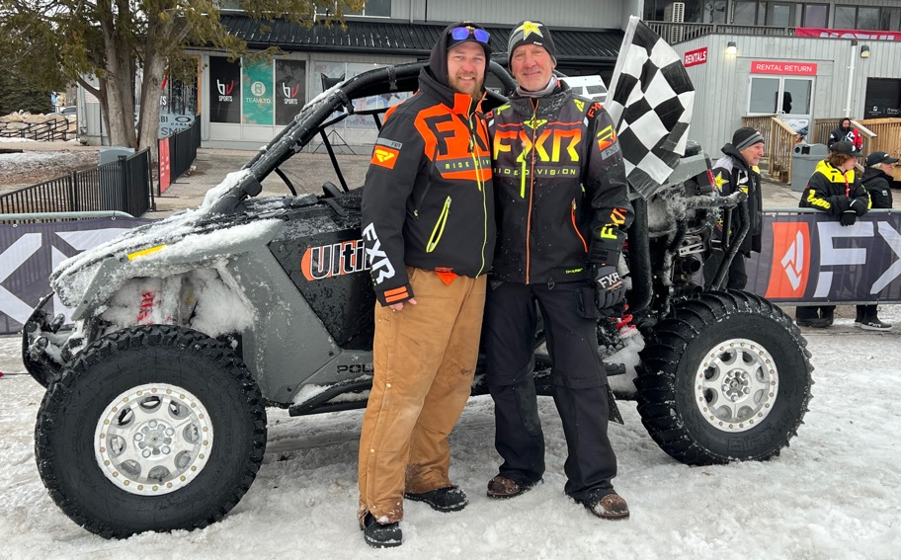
#72 Ken Avann is your 2023 UTV Production 1000cc Turbo season Champion! Avann takes home the grand prize of a brand new GMX AT4X sponsored by Tom Smith Chevrolet and True North Motorsports for a year!

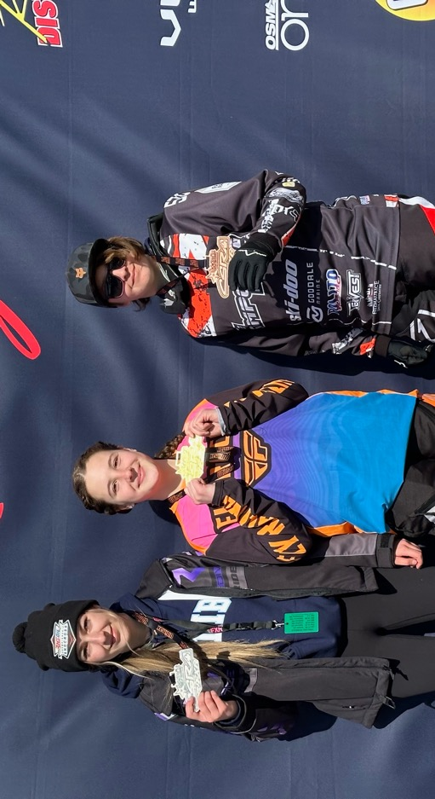
Results from Sundays Pro/Am Women’s class #501 Dakota Karkoulas (Ski-Doo, Bailey Motorsports) from Oakwood, ON was 1st. #144 Shyann Gosselin (Ski-Doo) from Kapuskasing, ON was 2nd and #574 Hailey Belanger (Bailey Motorsports, Ski-Doo) from Bracebridge, ON took home 3rd.

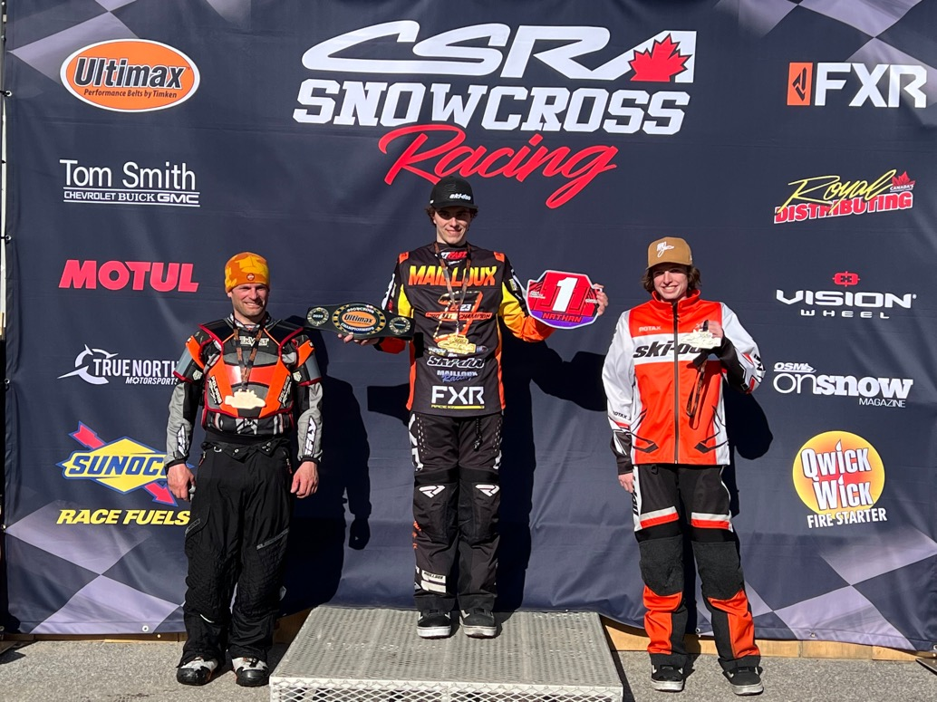
In the Pro-Lite Class #111 Nathan Mailloux (FXR Racing, Ski-Doo), Ste-Sophie, QC was 1st. #22 Hunter Scott (Motopark, Ski-Doo) from Oro-Medonte, ON was 2nd and #98 Michael Island (Polaris) from Coldwater, ON finished in 3rd. #111 Nathan Mailloux is the 2023 Pro-Lite Season Champion!

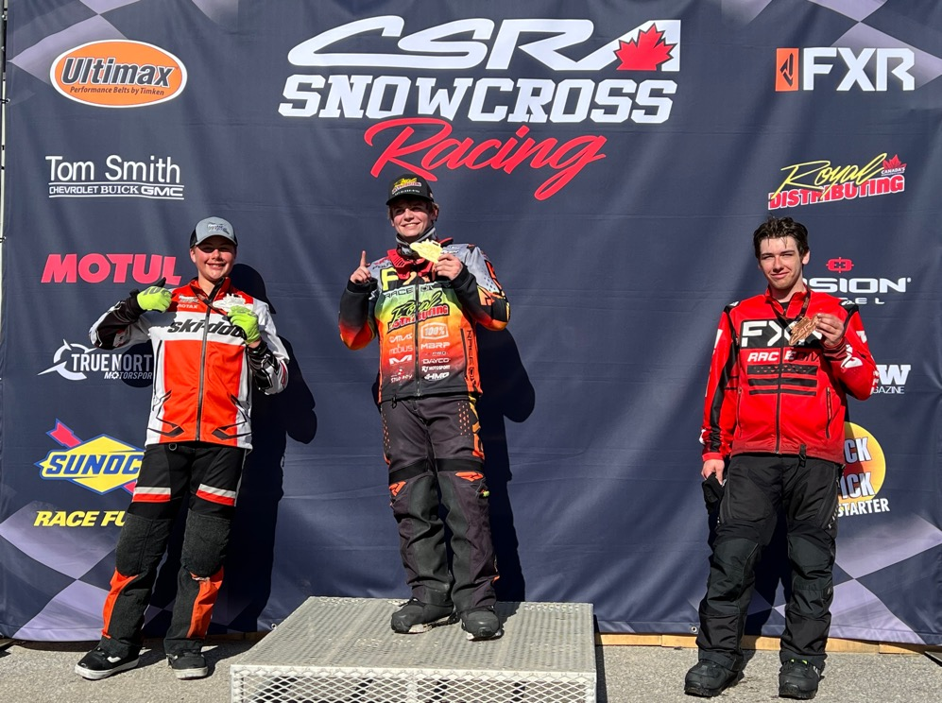
Sunday’s Sport 600 class was won by #458 Trent Weir (Royal Distributing, FXR, Polaris) from Bracebridge, ON. #281 Jacob Begin (Ski-Doo) from Saint Georges, QC 2nd and #632 Eric Bouskill (Ski-Doo) from Bracebridge, ON 3rd.

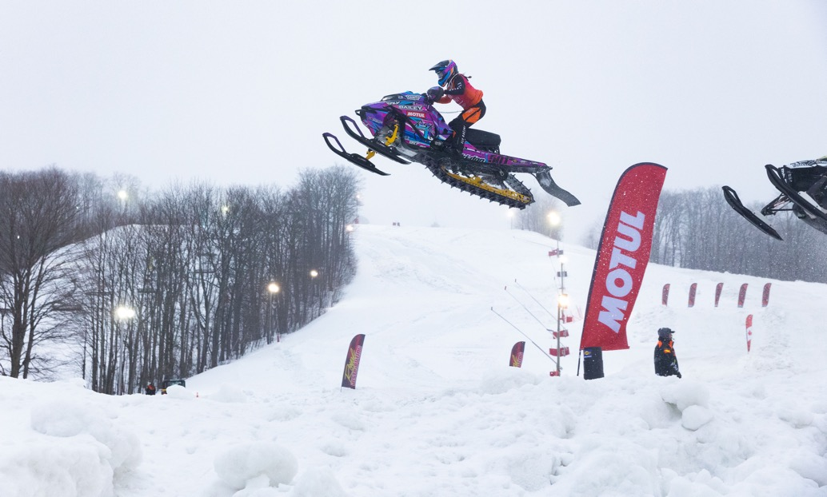
#501 Dakota Karkoulas (Ski-Doo, Bailey Motorsports) from Oakwood, ON finished off the 2023 season as the Pro/Am Womens Season Champion!

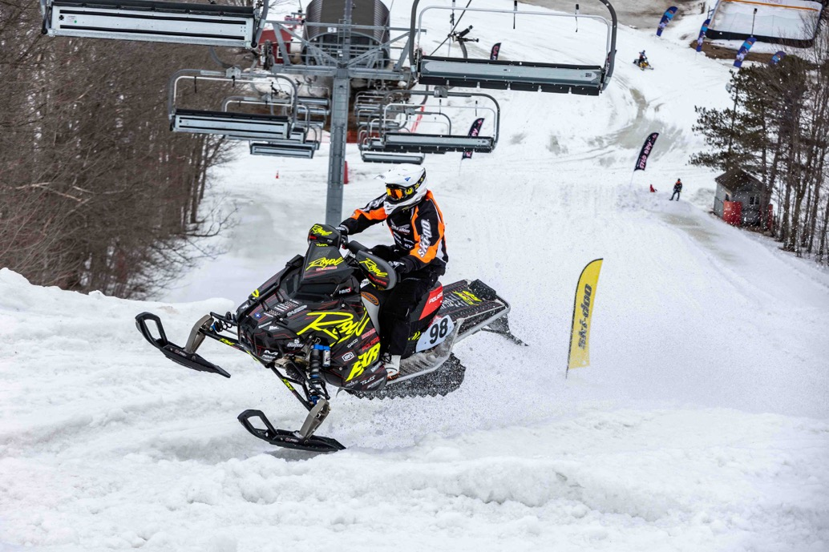
#98 Michael Island (Royal Distributing, Polaris) from Coldwater, ON made a return almost a decade after retiring from Snowcross. Island placed 2nd in Saturdays Pro-Lite final and 3rd in Sundays Pro-Lite final.

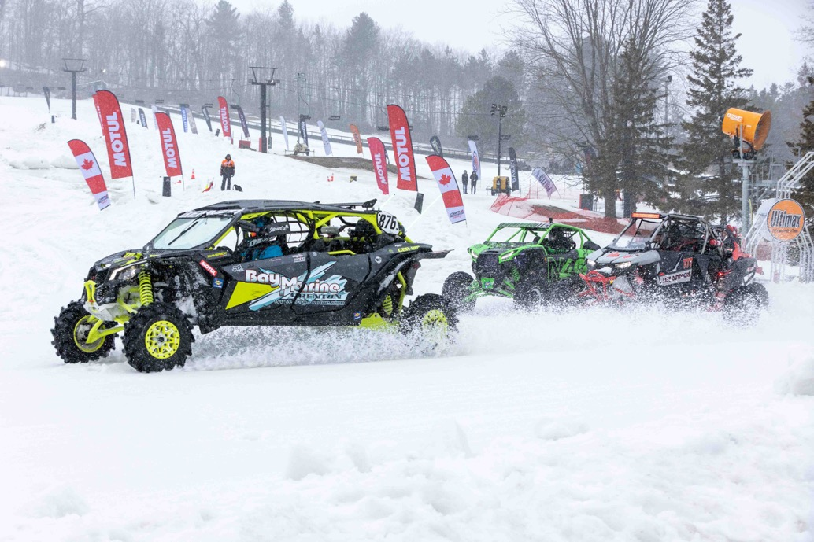
Our CSRA UTV Classes were filled with adrenaline and excitement with the season Championships on the line.
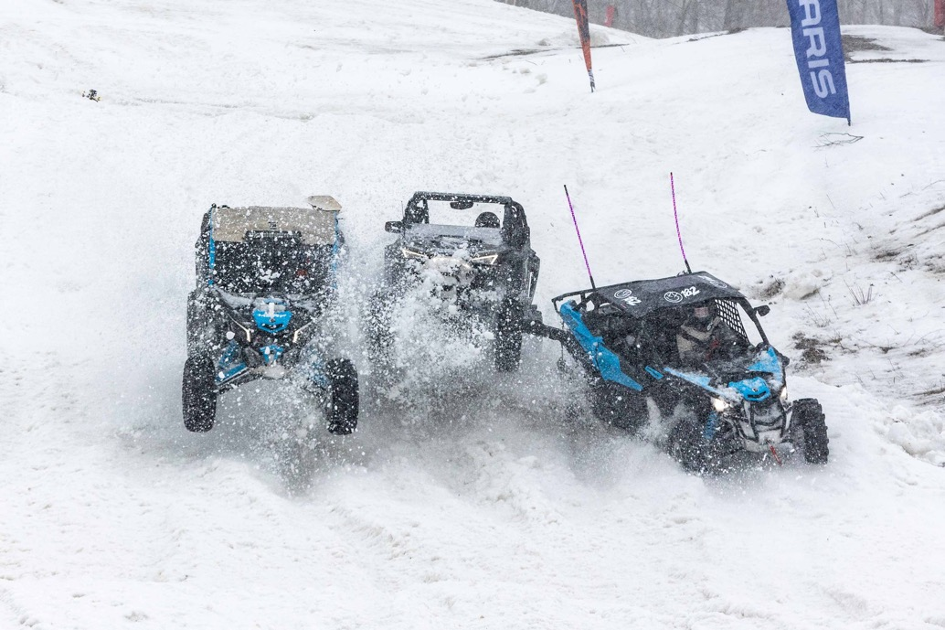
Racing the ski hills of Horseshoe Resort made for some series battles and crazy close calls!

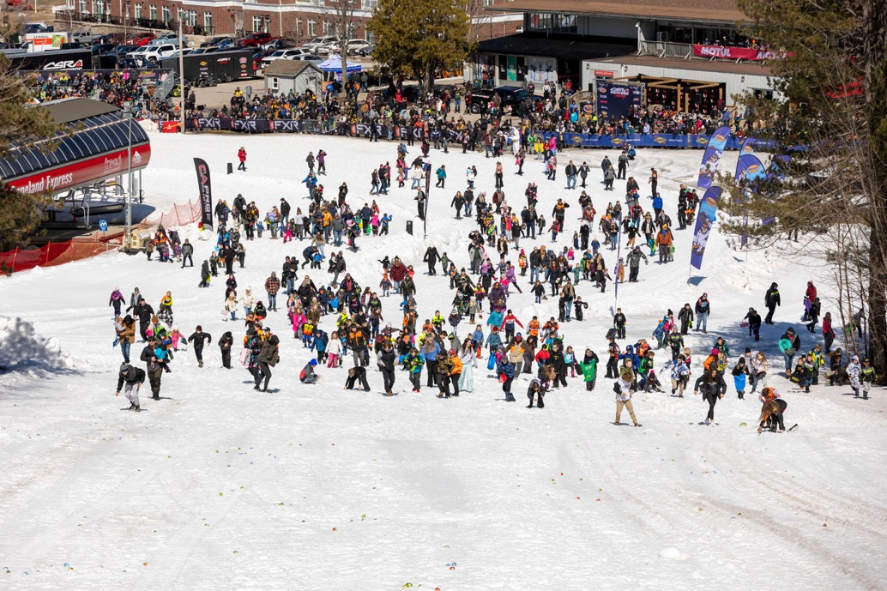
The CSRAs annual kids Easter Egg hunt was once again a “chocolate smashing” good time for all of those who made the mad dash!

